**QUESTION-ANSWER FORUM**

**Team VENUS**

Montclair State University

Computer Science Department

**Amy Caprioni**

**Eliezer Epstein**

**Supriya Karambe**

**Description of the Problem**

While the internet has allowed people to access a wide array of information in a short amount of time, finding accurate or relevant information is a different matter. For example, a student might type a question in Google and receive over 5 million results in 0.60 seconds, but how many of those answers are correct and will the answers be given in a such a way that the student can understand them?

**Objectives**

In order to solve this problem Team Venus is proposing to build a question-and-answer forum app which will act as a space for users to receive not just an answer, but the correct answer, with opportunities for further discussion and feedback. The app will contain the following features:

* Registration process for a unique username and password
* The ability to post questions and answers to the forums (with the user displayed) as well as being able to comment on previous questions or answers
* Anonymous liking/unliking to act as feedback for the relevance or correctness of a given answer
* Organization of the forum by pre-existing topics as well as user-generated topics if a question does not fall into a predetermined area.
* A search bar to see if a topic or question has already been covered to look for answers
* A metric that utilizes the likes for a given post or comment to organizes by popularity
* A unique portfolio page for each user which will appear immediately upon login where they can see what and where they have posted most recently. In addition, the portfolio page will include a feed of recent posts that are of interest to the user

**Originality and Social Impact**

While a forum app itself is not a novel idea, the project our group is proposing will be focused on Montclair State University students. As such, we foresee a number of unique possibilities for this app as it evolves. The basic app will allow users to create new topics and posts within those topics - these topics can be based on a particular subject (i.e., Biology, Chemistry, Computer Science, etc) or might focus on an individual class (i.e., CSIT-501, 502, etc). This will create a new environment for students to interact, solve problems and receive input from their professors. Additionally, school administrators might be able to use it as a snapshot of what areas students are having issues with, which classes might need to be reformatted and perhaps a more honest assessment of teachers’ qualities (as forum users will have the ability to choose their own username and remain anonymous).

**Target Audience**

Our target audience will be anyone with a ‘montclair.edu’ email address - this includes students, teachers, and faculty. It will be an ideal place for students to interact with one another, furthermore, professors will be able to connect with their students more directly to address specific issues outside of office hours and the current online campus system. Finally, faculty members will be able to join in as well so that they can get a better idea of some of the areas students are having difficulty with for improvement.

**Development Timetable**

**Phase 1**

Login And Registration Module- Week 9

Login , Portfolio Page - Eliezer Epstein

Registration- Supriya Karambe

Forgot Or reset Password- Amy Caprioni

Functional Testing- Supriya Karambe

**Phase 2**

User Activity Module- Week 10

Add And Search Question- Supriya Karambe

Add Comment, Like and dislike Comment- Eliezer Epstein

Add Topic to favorite, Show recent activity- Amy Caprioni

Functional and Integration Testing- Amy Caprioni

**Phase 3**

Campus Updates- Week 11

Show campus related news Amy Caprioni

Upcoming event in university Supriya Karambe

Functional and Regression Testing Eliezer Epstein

**Phase 4**

Integration- Week 12

Final integration of all module And Documentation Eliezer, Amy and Supriya

Software Testing

**Preliminary Designs and Wireframing**

The following flow chart explain high level design of Project -Question Answer Forum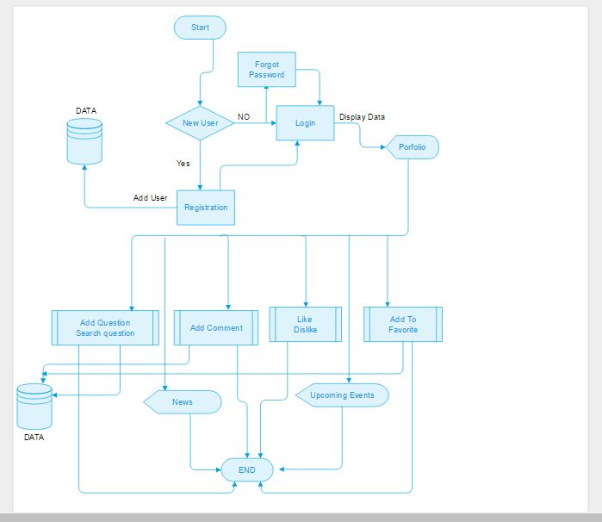

The following wire framing demonstrates the layout of the different pages of the app:

Registration Section:

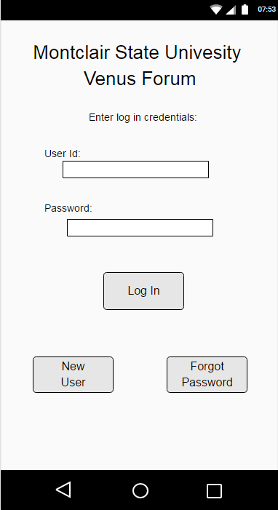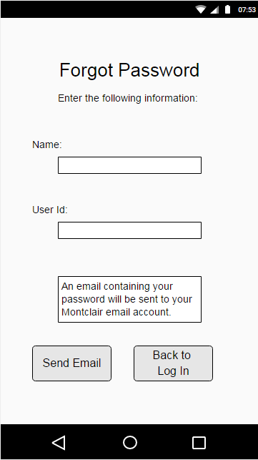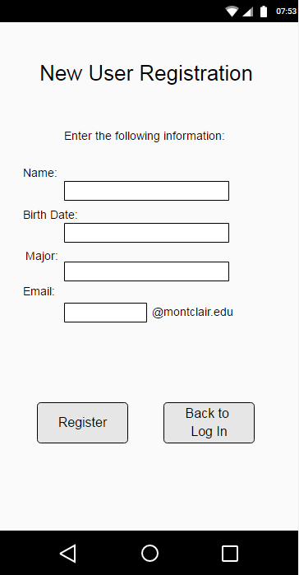

Forum Section:

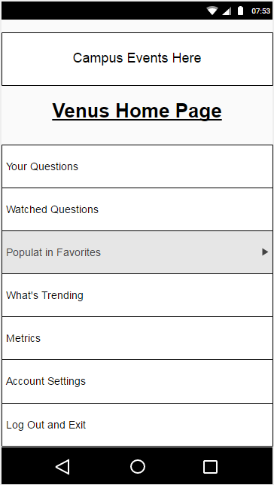  
This is the user’s home page. This is the first page the user is directed to when they log in. The user has the ability to make several choices:  
  
Your Questions: Takes user to the list of their questions.  
Watched Questions: Allows users to see all the questions that they have watched (clicked the eye icon on the question forum page).  
  
Popular in Favorites: Allows users to see the most popular questions in topics in which they have favorited (clicked the star icon on the topic forum page).  
  
What’s Trending: Displays the most popular questions on the application.  
  
Metrics: Takes user to a page which displays metrics on the different topics. Metrics include statistics like popularity of topics, number of likes, majors of users commenting on topics, etc.  
  
Account Settings: Allows users to edit their account settings. (For example, password and email).

The follow three sets of pictures depict the screens and menu bar for the topic forum page, question forum page, and answer page respectively.

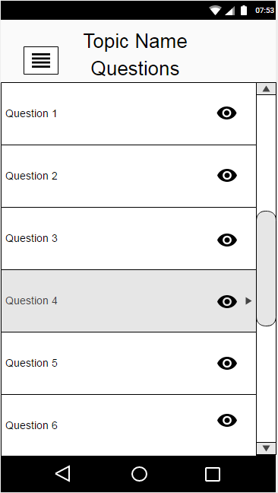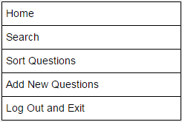

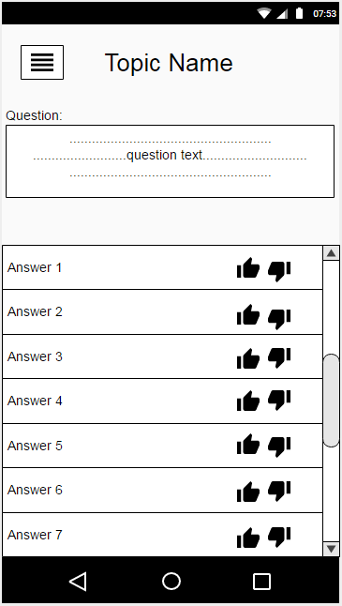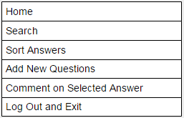

(All above wireframing was accomplished using the online tool moqups.com)